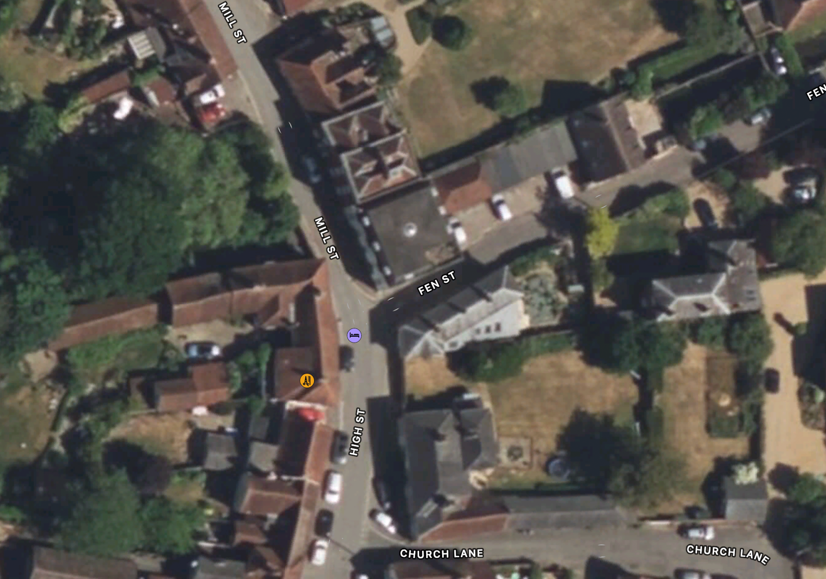

430cm

400cm

230cm

230cm

Wooden bollards

292cm

Kerb Line

Pavement

Carriageway