GRID CONNECTION
STATEMENT OF COMMON GROUND
BETWEEN
GREEN SWITCH CAPITAL LIMITED
&
BABERGH DISTRICT COUNCIL
&
BENTLEY PARISH COUNCIL AND STOP GROVE FARM SOLAR (R6 Party)

SECTION 78 APPEAL BY GREEN SWITCH CAPITAL LIMITED

LAND AT GROVE FARM AND LAND EAST OF THE RAILWAY LINE, BENTLEY, IP9 2BZ

PROPOSAL:
FULL PLANNING APPLICATION – CONSTRUCTION OF A SOLAR FARM (UP TO 40MW EXPORT CAPACITY) WITH ANCILLARY INFRASTRUCTURE AND CABLING, DNO SUBSTATION, CUSTOMER SUBSTATION AND CONSTRUCTION OF NEW AND ALTERED VEHICULAR ACCESES
Signed:  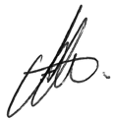 | Signed:  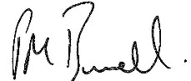 | 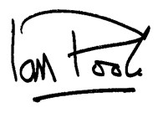  Signed:
Name: Steven Stroud | Name: Paul Burrell | Name: Ian Poole
On behalf of: Babergh District Council (the Local Planning Authority) | On behalf of: Pegasus Group (on behalf of the Appellant) | On behalf of: Rule 6 Party
Date: 10/02/26 | Date: 10/02/2026 | Date: 11/02/2026

Contents.
1. Introduction 3
2. NESO Grid Reform process overview 3
3. Grove Solar Farm - Gate 2 application events 3
4. Grove Solar Farm – current status of Gate 1 offer 3
5. CMP448: Introducing a Progression Commitment Fee to the Gate 2 Connections Queue 5

- Introduction
  - This Grid Connection Statement of Common Ground (“SoCG”) seeks to identify the areas where the principal parties (the Appellant, the LPA and the Rule 6 Party) are in agreement in the matter of grid connection and the ongoing reform process being undertaken by NESO.

- NESO Grid Reform process overview
  - The Parties agree that given the uncertainty as to the enforcement of Grid offer milestones, the grid offer system accumulated “zombie projects” where no effective progress was being made which blocked the delivery of “real” developments.
  - The Parties agree that the new regime was therefore changed to “first ready, first connected”.
  - The Appellant understands that a number of Gate 2 offers were made to projects that had not secured planning permission prior to receiving a Gate 2 offer. The Council has been unable to corroborate this, but the parties agree that many projects with planning permission did not receive a Gate 2 offer. A reason many such projects have not received a Gate 2 offer is explained by NESO at Q&A q.51 where it is stated:
“Technology based targets have been established using the UK Government 2024 Clean Power 2030 Action Plan (Table 1, page 32 - DESNZ ‘Clean Power Capacity Range’. Available at: https://www.gov.uk/government/publications/clean-power-2030-action-plan). This report sets out that 45-47GW is required by 2030, with around 16.6GW already installed. The existing levels of solar in the old connection queue amounted to around 210GW, four times the 2030 target. Almost 60GW of solar is in the new delivery pipeline.”
  - There is currently no published list of Gate 2 projects, and the delivery pipeline is anonymised.

- Grove Farm Solar - Gate 2 application events
  - Grove Solar Farm Gate 2 readiness criteria were submitted by the Appellant on 20th June 2025.
  - UKPN (as the District Network Operator) were informed of dates of Grove Solar Farm planning inquiry by the Appellant on 15th September 2025.
  - On 9th December 2025, Grove Farm received notification of Gate 1 status which is a process governed by NESO (National Energy System Operator). The consequence of Gate 1 is that the existing contracted connection offer is removed, including any queue position (CD-D37, Q&A no.6). The queue position and connection date for Grove Farm Solar are therefore presently unknown.

- Grove Farm Solar - current status of Gate 1 offer
  - Relevant guidance on Gate 2 Criteria Methodology has just been published on 21st January 2026 (new CD- D38).
  - The Parties agree that this project will benefit from this ‘protected status’ under CMP434 Clause 3a, as the Grove Solar Farm planning application was validated on 7th December 2023).
  - An extract set out below explains the implications of ‘protected status’ which is set out in Protection Clause 3a, which means that once planning permission is obtained, the developer is able to apply for connection in the next round of Gate 2 submissions (alongside any other new or existing applicants), which are to be held every 6 months and each window will last 6 weeks. The next window will open no earlier than Q2 2026:
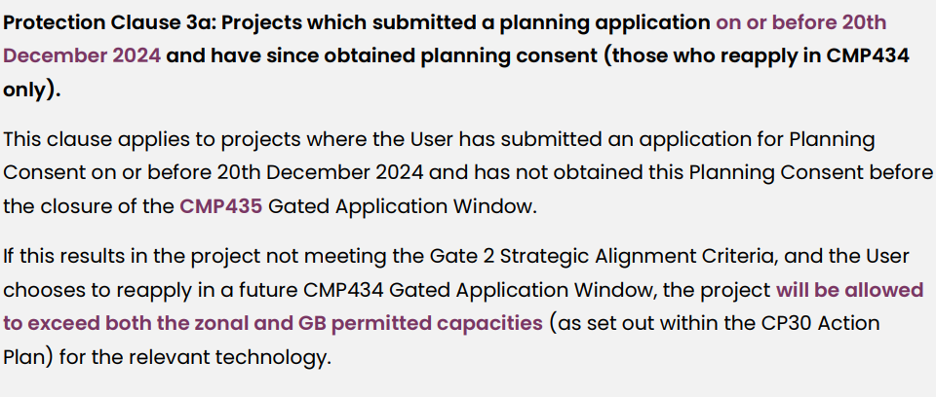
  - If planning permission is granted following this appeal at Grove Farm, the Parties acknowledge that the Appellant’s intention would be to make a further Gate 2 Grid application to the next round of Gate 2 expected no earlier than Q2 2026 (see CD- D37, Q&A, no.35), and as per Clause 3a above, such a Gate 2 Grid Offer would be allowed to exceed both the zonal and GB permitted capacities. (see CD-D37, Q&A, no. 42).
  - The protection clauses in the Gate 2 Criteria Methodology contain no assurance on dates; in other words, they protect a customer’s place in the delivery pipeline but not their connection date (CD-D37, Q&A, no. 7). Q&A no.42 states that projects protected under Clause 3a would go to the back of the new connections pipeline with the exceptions of where projects have been removed and where allocated capacity has not been used.
  - Whilst the first stage of the queue formation process is complete at this point in time in respect of Gate 2 Phase 2 (pre 2035) and Gate 2 Phase 1 (pre 2030), , it is clear that there are 2 potential mechanisms by which earlier connection dates can be received, including where capacity can be reallocated if Gate 2 projects withdraw or are removed from the connection pipeline. It is agreed that an applicant can request an earlier connection date (CD-D37, Q&A q.24).
  - A pre-2030/Phase 1 connection date remains a date that could, in theory, be delivered by the developer (this would be reliant upon other projects being removed from the delivery pipeline and what can be accommodated by the DNO), however it cannot be said with certainty what the Gate 2 connection date will be once Gate 2 status is achieved. Only at the point of a Gate 2 offer being made will a firm date be given, but due to it being a Gate 2 offer, the latest date of connection would have to be prior to 2035.
  - Subject to zonal and GB permitted capacities, it is feasible for other developments to enter the delivery pipeline following application in future Gate 2 windows. However, new projects would not benefit from protected clause 3a status, nor would their export capacities be protected as in the case of Grove Farm.

- CMP448: Introducing a Progression Commitment Fee to the Gate 2 Connections Queue
  - The Parties agree that CMP448 establishes a framework to introduce an additional financial requirement on developers, that can be activated if required, to incentivise the timely removal of unviable projects from the connections queue and facilitate the more timely and efficient connection of viable projects.
  - It is noted that there is a requirement for a Progression Commitment Fee (“PCF”) to be paid between the period of accepting a Gate 2 connection offer and achieving queue management milestone 1 (M1: submitting planning application). The removal of unviable projects in the queue at the earliest opportunity is stated to ensure a more reliable connections pipeline that improves the efficiency and economy of network planning and support the achievement of Clean Power 2030 Action Plan (CP2030) targets. The proposed fee is designed to incentivise regular assessment of project viability if the connections queue is in poor health and CP2030 may be at risk.
  - It is noted that in order to incentivise a regular assessment of project viability, the PCF has a profile that starts at £2,500/MW and increases by £2,500/MW every six months until it reaches a cap of £10,000/MW. The PCF would be treated as a cancellation charge and CUSC Users would be required to post a security against the PCF which will remain in place until they have successfully achieved QM M1. After the User has passed M1, the requirement to securitise the PCF will fall away and the amount paid will be returned.
  - The implication of this clause is that projects will now be required to face a financial penalty for not progressing and the removal of unviable projects through this mechanism may increase previous attrition rates for those projects now in the Gate 2 connections queue.

NOMICS | ENVIRONMENT | HERITAGE | LAND & PROPERTY | PLANNING | TRANSPORT & INFRASTRUCTURE

Official statistics show that UK solar deployment reached c.21GW by November 2025 (leaving, in broad terms, c. 24-26GW to be delivered by 2030).

