FRESTON

HOUSING & POPULATION DATA PROFILE
[Parish level]

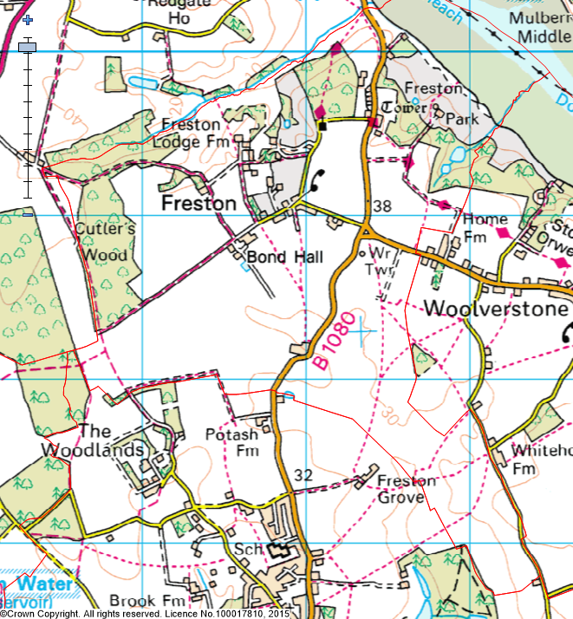

(Last Updated: October 2019)

This Parish Profile has been produced primarily to help inform local discussion on housing need
Most of the data comes from the 2011 Census (accessible via the ONS website)
Other data sources have also been used as appropriate, and will be updated periodically

How many people live locally? | Children Under  16 | Working  Age Adults  (16 to 64) | People  Aged  65 + | Dependency Ratio
120 | 21 (17.5%) | 74 (61.7%) | 25 (20.8%) | 0.62
55.8% Males  44.2% Females | Babergh Avg = 18.1%  England Avg = 18.9% | Babergh Avg = 60.5%  England Avg = 64.7% | Babergh Avg = 21.4%  England Avg = 16.3% | Babergh Avg = 0.65  England Avg = 0.55

[Source: ONS 2011 Census: KS101EW & KS102EW] [Dependency Ratio = Ratio of Non-working Age to Working Age Population]

Single Pensioner Households | Single H/holds  < 65 years old | Lone Parent Families  with Dependent Children
8 | 8 | 1
15.4% of all Households  (Babergh Avg = 14.1%)  (England Avg = 12.4%) | 15.4% of all Households  (Babergh Avg = 14.0%)  (England Avg = 17.9%) | 9.1% of all families with dependent children  (Babergh Avg = 19.1%)  (England avg = 24.5%)

[Source: ONS 2011 Census: KS105EW]

General Health (All Usual Residents)

Very Good  49.2% | Good  39.2% | Fair  10.0% | Bad  1.6% | Very Bad  0%
Babergh Avg = 46.6%  England Avg = 47.2% | Babergh Avg = 35.8%  England Avg = 35.2% | Babergh Avg = 13.2%  England Avg = 12.8% | Babergh Avg = 3.5%  England Avg = 3.6% | Babergh Avg = 0.9%  England Avg = 1.0%

[Source: ONS 2011 Census: QS302EW]

Total # Occupied  Households | Owned (Outright or with Mortgage) | Shared Ownership | Socially  Rented | Privately  Rented
52 | 29 (55.8%) | 0 (0%) | 0 (0%) | 23 (44.2%)
 | Babergh Avg = 71.9%  England Avg = 63.3% | Babergh Avg = 0.5%  England Avg = 0.8% | Babergh Avg = 13.1%  England Avg = 17.7% | Babergh Avg = 12.6%  England Avg = 16.8%

[Source: ONS 2011 Census: QS405EW]
- At the time of the 2011 Census some 6 dwellings (10.5% of all dwellings in Freston) appeared to be unoccupied. (Babergh Avg = 3.8%) [QS418EW]
Number of Bedrooms (Occupied Households)

None | 1 bed | 2 bed | 3 bed | 4 bed +
0 (0%) | 1 (1.9%) | 9 (17.3%) | 24 (46.2%) | 18 (34.6%)
Babergh Avg = 0.1%  England Avg = 0.2% | Babergh Avg = 6.3%  England Avg = 11.8% | Babergh Avg = 25.4%  England Avg = 27.9% | Babergh Avg = 42.0%  England Avg = 41.2% | Babergh Avg = 26.2%  England Avg = 18.9%

[Source: ONS 2011 Census: QS411EW]

Total # Occupied  Households | Total # with Under-Occupied bedrooms | Total # with Over-Occupied bedrooms
52 | 48 (92.3%) | 0 (0%)
 | Babergh Avg = 80.6% / England Avg = 68.7% | Babergh Avg = 1.5% / England Avg = 4.6%

[Source: ONS 2011 Census: QS412EW]

NET NEW RESIDENTIAL COMPLETIONS (Last 5 Years: April to March)
2013/14 | 2014/15 | 2015/16 | 2016/17 | 2017/2018
0 | 0 | 0 | 0 | 0

[Source: Babergh & Mid Suffolk Planning Policy Monitoring Data]

Avg Price & No (in brackets) of Properties Sold in IP9 Postcode Area (Aug 2015)
Detached | Semi-Det’ | Terraced | Flat | All
£353,623 (10) | £198,429 (7) | £307,100 (5) | £65,000 (1) | £283,727 (23)

[Source: Right Move website: Market Trends]

BABERGH
In Babergh, in 2017 …the average wage was £24,499. The average house price was £269,498. Therefore, the wage to house price ratio = x 11.00
[Source: ONS website: Median wages, median house prices and ratio calculation]

Other Information

- County Councillor = Cllr David Wood (Peninsula Division)

- District Councillors = Cllr Jane Gould (Orwell Ward)

- Freston is identified as a Countryside Village in Policy CS2 of the Babergh Local Plan 2011-2013 (Core Strategy & Policies) DPD (Adopted Feb 2014)

- Freston is part of a wider ‘functional cluster’ that is centred on the Core Village of Holbrook

- Like many small settlements, there are very few local services available in Freston

- 65% of all households in Freston with at least one usual resident are reliant on oil-fired heating [QS415EW]

- There are no Housing Association’s (Registered Providers) currently known to be active in Freston

- The 2014 Suffolk Housing Survey shows that, across Babergh district:

  - 12% of all existing households contain someone looking for their own property over the next 3 years (mainly single adults without children). The types of properties they are interested in are flats / apartments, and smaller terraced or semi-detached houses. Although this is not their first preference, many accept that the private rented sector is their most realistic option

  - 25% of households think their current property will not be suitable for their needs in 10 years’ time

  - 2 & 3 bed properties are most sought after by existing households wishing to move.

  - Suitable housing options for more elderly people are less available within the current housing stock. 6% of all households have elderly relatives who may need to move to Suffolk within the next 3 years

