FELSHAM

HOUSING & POPULATION DATA PROFILE
[Parish level]

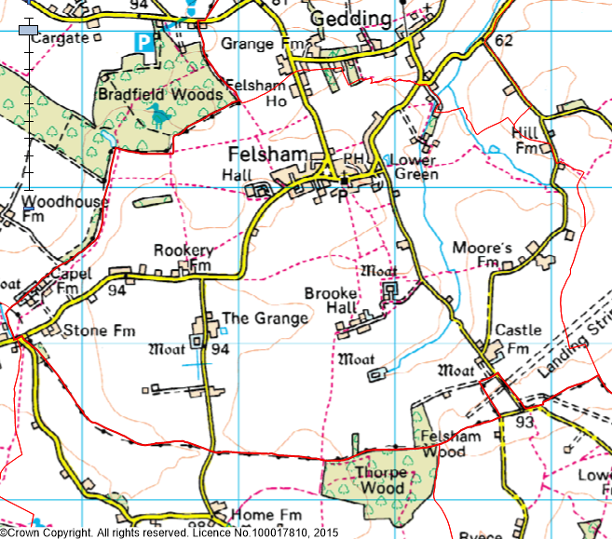
(Last Updated: October 2019)

This Parish Profile has been produced primarily to help inform local discussion on housing need.
Most of the data comes from the 2011 Census (accessible via the ONS website). Other data sources have also been used as appropriate, and will be updated periodically.

How many people live locally? | Children Under  16 | Working  Age Adults  (16 to 64) | People  Aged  65 + | Dependency Ratio
448 | 78 (17.4%) | 275 (61.4%) | 95 (21.2%) | 0.63
49.6% Males  50.4% Females | Mid Sflk Avg = 18.4%  England Avg = 18.9% | Mid Sflk Avg = 61.5%  England Avg = 64.7% | Mid Sflk Avg = 20.1%  England Avg = 16.3% | Mid Sflk Avg = 0.63  England Avg = 0.55

[Source: ONS 2011 Census: KS101EW & KS102EW] [Dependency Ratio = Ratio of Non-working Age to Working Age Population]

Single Pensioner Households | Single H/holds  < 65 years old | Lone Parent Families  with Dependent Children
32 | 12 | 4
17.2% of all Households  Mid Suffolk Avg = 12.9%  England Avg = 12.4% | 6.5% of all Households  Mid Suffolk Avg = 12.4%  England Avg = 17.9% | 7.8% of all families with dependent children  Mid Suffolk Avg = 17.7%  England avg = 24.5%

[Source: ONS 2011 Census: KS105EW]

General Health (All Usual Residents)

Very Good  47.1% | Good  36.6% | Fair  12.0% | Bad  3.6% | Very Bad  0.7%
Mid Sflk Avg = 47.9%  England Avg = 47.2% | Mid Sflk Avg = 35.3%  England Avg = 35.2% | Mid Sflk Avg = 12.8%  England Avg = 12.8% | Mid Sflk Avg = 3.1%  England Avg = 3.6% | Mid Sflk Avg = 0.8%  England Avg = 1.0%

[Source: ONS 2011 Census: QS302EW]

Total # Occupied  Households | Owned (Outright or with Mortgage) | Shared Ownership | Socially  Rented | Privately  Rented
186 | 135 (72.6%) | 1 (0.5%) | 31 (16.7%) | 15 (8.1%)
 | Mid Sflk Avg = 75.1%  England Avg = 63.3% | Mid Sflk Avg = 0.8%  England Avg = 0.8% | Mid Sflk Avg = 11.3%  England Avg = 17.7% | Mid Sflk Avg = 11.2%  England Avg = 16.8%

[Source: ONS 2011 Census: QS405EW]
- At the time of the 2011 Census some 3 dwellings (1.6% of all dwellings in Felsham) appeared to be unoccupied. (Mid Suffolk Avg = 3.8%) [QS418EW]
Number of Bedrooms (Occupied Households)

None | 1 bed | 2 bed | 3 bed | 4 bed +
0 (0%) | 16 (8.6%) | 31 (16.7%) | 64 (34.4%) | 75 (40.3%)
Mid Sflk Avg = 0.1%  England Avg = 0.2% | Mid Sflk Avg = 6.0%  England Avg = 11.8% | Mid Sflk Avg = 25.0%  England Avg = 27.9% | Mid Sflk Avg = 40.4%  England Avg = 41.2% | Mid Sflk Avg = 28.5%  England Avg = 18.9%

[Source: ONS 2011 Census: QS411EW]

Total # Occupied  Households | Total # with Under-Occupied bedrooms | Total # with Over-Occupied bedrooms
186 | 149 (80.1%) | 2 (1.0%)
 | Mid Sflk Avg = 80.8% / England Avg = 68.7% | Mid Sflk Avg = 1.6% / England Avg = 4.6%

[Source: ONS 2011 Census: QS412EW]

NET NEW RESIDENTIAL COMPLETIONS (Last 5 Years: April to March)
2013/14 | 2014/15 | 2015/16 | 2016/17 | 2017/2018
6 | 0 | 0 | 1 | 6

[Source: Babergh & Mid Suffolk Joint Annual Monitoring Report]

Avg Price & No (in brackets) of Properties Sold in IP30 Postcode (Aug 2018)
Detached | Semi-Det’ | Terraced | Flat | All
£519,792 (6) | £264,333 (6) | £247,998 (10) | £0 (0) | £326,578 (22)

[Source: Right Move website: Market Trends]

MID SUFFOLK
In Mid Suffolk, in 2017 …the average wage was £25,070. The average house price was £255,000. Therefore, the wage to house price ratio = x 10.17
[Source: ONS website: Median wages, median house prices and ratio calculation]

Other Information

- County Councillor = Cllr Penny Otton (Thedwastre South Division)

- District Councillor = Cllr Penny Otton (Rattlesden Ward)

- Felsham is identified as a Secondary Village in Policy CS1 of the Mid Suffolk Core Strategy DPD (Adopted Sept 2008)

- Local Services in Felsham include … a Church, Village Hall, Shop / Post Office, Garage and Public House

- 63% of all households in Felsham with at least one usual resident are reliant on oil-fired heating [QS415EW]

- Felsham Parish Council, working with Gedding Parish Council, published their Parish Plan in 2012

- One Housing Association (Registered Provider) is currently known to be active in Felsham. They are Orwell Housing

- The 2014 Suffolk Housing Survey shows that, across Mid Suffolk district:

  - 12% of all existing households contain someone looking for their own property over the next 3 years (mainly single adults without children). The types of properties they are interested in are flats / apartments, and smaller terraced or semi-detached houses. Although this is not their first preference, many accept that the private rented sector is their most realistic option.

  - 25% of households think their current property will not be suitable for their needs in 10 years’ time.

  - 2 & 3 bed properties are most sought after by existing households wishing to move.

  - Suitable housing options for more elderly people are less available within the current housing stock. 6% of all households have elderly relatives who may need to move to Suffolk within the next 3 years.

